

Project Name- Hotel Skyview

Name: Kazi Abid Shahoriar

GitHub- <https://github.com/Abid1285>

ID: 2211967042

Name: Nafis Fuhad

GitHub- https://github.com/NafisFuhad

ID: 2132307642

Name: Ashfak Uddin Tanjim

GitHub- <https://github.com/AshfakUddin07>

ID: 2232205042

Section: 05

Introduction:

The Hotel Skyview Management System is a web-based application developed to streamline and enhance the management of Hotel Skyview. This Java-based project aims to provide an efficient and user-friendly platform for hotel staff to manage various aspects of hotel operations, from room bookings to guest services. The system is designed to automate and optimize day-to-day tasks, resulting in improved efficiency and customer satisfaction.

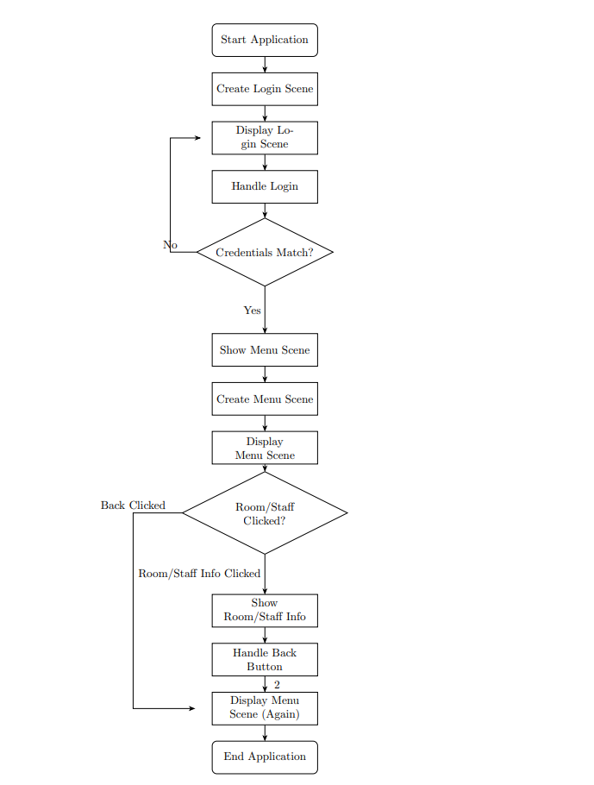

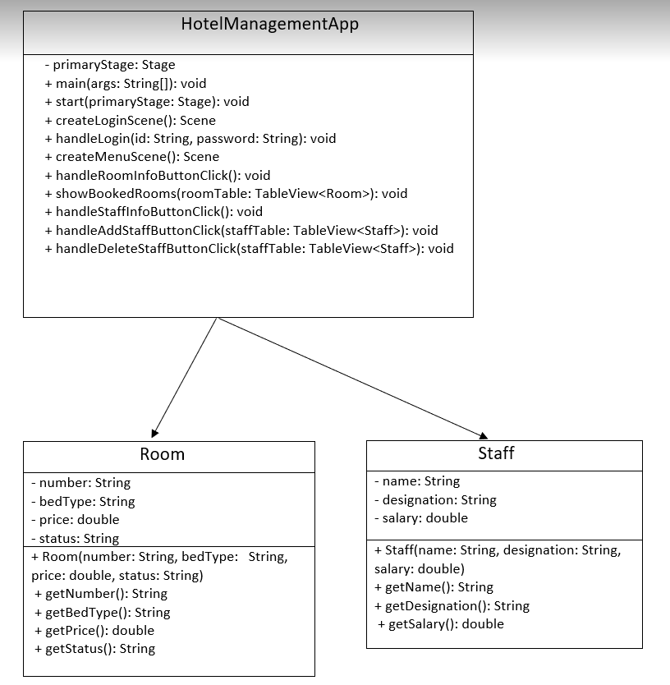

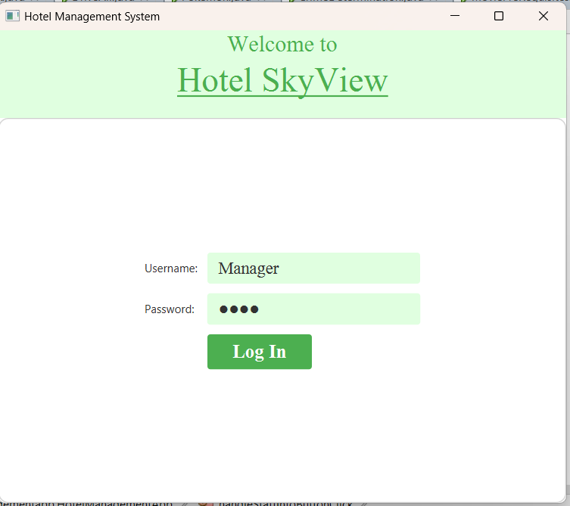

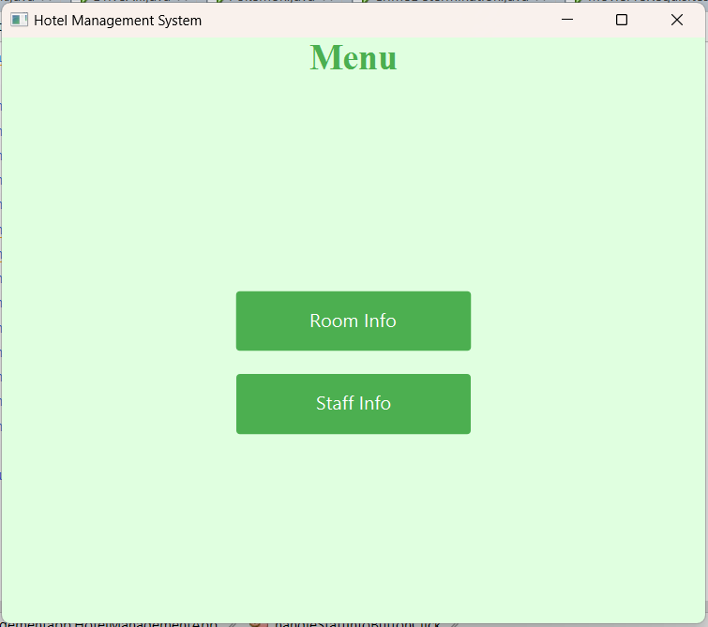

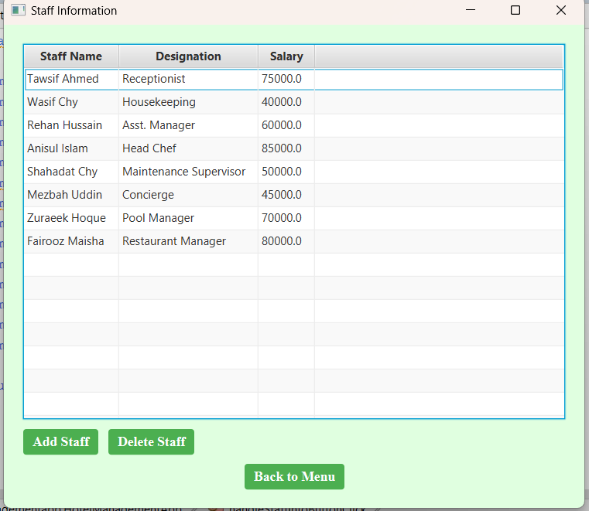

Improvements- We wish to include a user login option as this is a basic version with only management login. Moreover, facilities for check-in and check-out will be introduced. After that, we will add transactions and monthly expenses.